Replace “**What SEO Services**” with “**What Are SEO Services**”



Use this **Optimize| Elevate| Rank**

Replace from **Because Performance is Everything**



Use **Draw 100% Organic Traffic** & Replace **“Draw Organic Traffic”**

**Add para below this heading**

**Quality Optimization Process**

We provide a top-notch & effective optimization process that ensures your website is kept up-to-date with the latest search engine algorithms and changing trends.

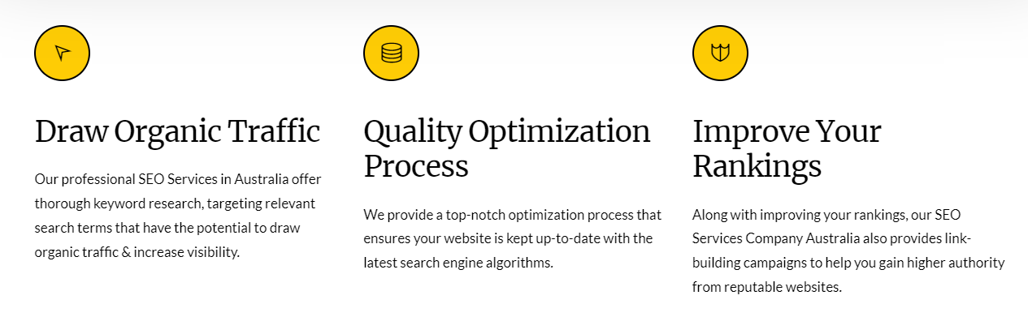

**Add all this given below this given heading**

**Analyze Your Business**

Our SEO Services Australia process begins with an in-depth analysis of your business, including assessing your current website architecture, keyword research, and review of the content on your website. At GlobalSync, we are dedicated to helping you reach more customers online and will conduct a thorough analysis of all aspects of your business to ensure that our services are tailored precisely to meet your needs.

* Conduct Market Research
* Gather Keyword Data
* Optimize Website Content
* Increase Website Traffic

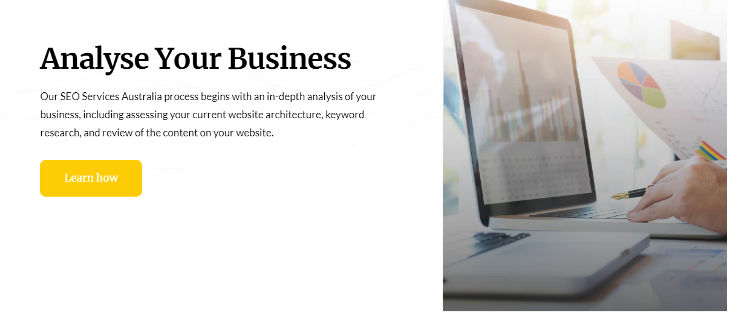

Add below the para of **“Make Strategy Accordingly“**

* Create Actionable Plan
* Analyze Data Metrics
* Utilize SEO Techniques
* Monitor Performance Results

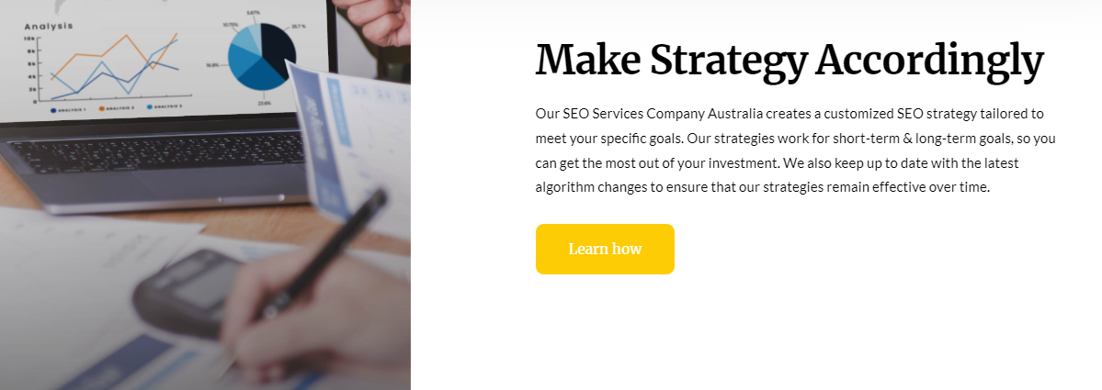

Add below the para of “**Integration**“

* Develop Custom Solutions
* Create Innovative Architectures
* Engineer Robust Integrations
* Develop Efficient Processes

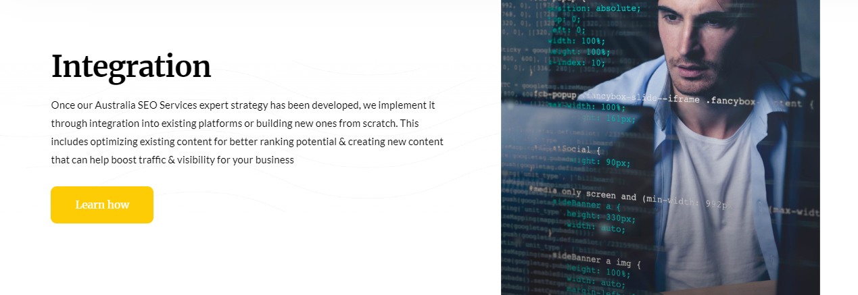

Add these three after these two pointers “**Fully Customized Strategies**

#### **Advanced Analytics and Insights”**

* Maximum Organic Visibility
* Comprehensive Market Analysis
* Cutting-Edge Technical Expertise

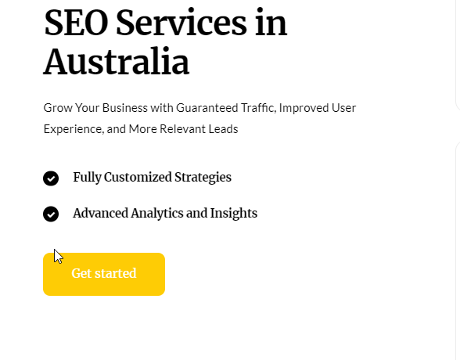

**Add the below para under the below heading**

**Driven Organic Traffic with Effective Strategy**

Our SEO strategies helped our client get positive results. These tactics included creating relevant content that resonated with their target audience, optimizing existing pages and content for search engine crawlers, creating backlinks from authoritative websites to help boost rankings, and identifying keyword opportunities.

Organic search traffic increased by over 300% within three months of launching the campaign and continued to grow as we continued to optimize their website for better rankings.

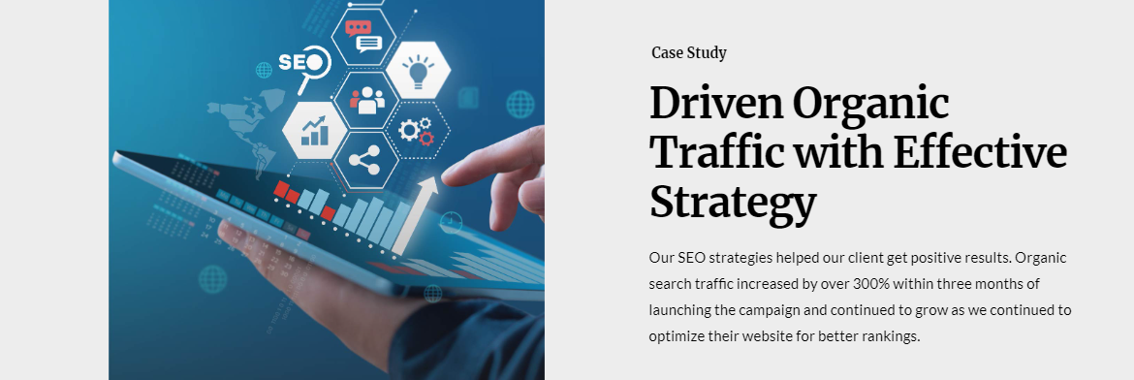

**FAQs**

**Q5. How does keyword analysis help with SEO?**

A: Keyword analysis is one of the most important components of SEO because it helps determine which words or phrases people use when looking for a product or service. By researching and analyzing the keywords that people use in their searches, you can ensure that your content contains those words or phrases so that it will show up higher in search engine results pages (SERPs). This increases the chances that prospective customers will see your website and make a purchase from you.

**Q6. How Long Does It Take To See Results From An SEO Campaign?**

The amount of time it takes for an SEO campaign to start generating results depends largely on the competitiveness of your industry as well as how quickly changes can be implemented on your website or web pages. Generally speaking, though, it’s best to give an SEO campaign at least 3-6 months before expecting any significant returns in terms of rankings or traffic.

**Become a GlobalSync Professional NOW**

